Statistics Canada Top 10 causes of death (2019 to 2022)

<https://www150.statcan.gc.ca/n1/daily-quotidien/231127/t001b-eng.htm>

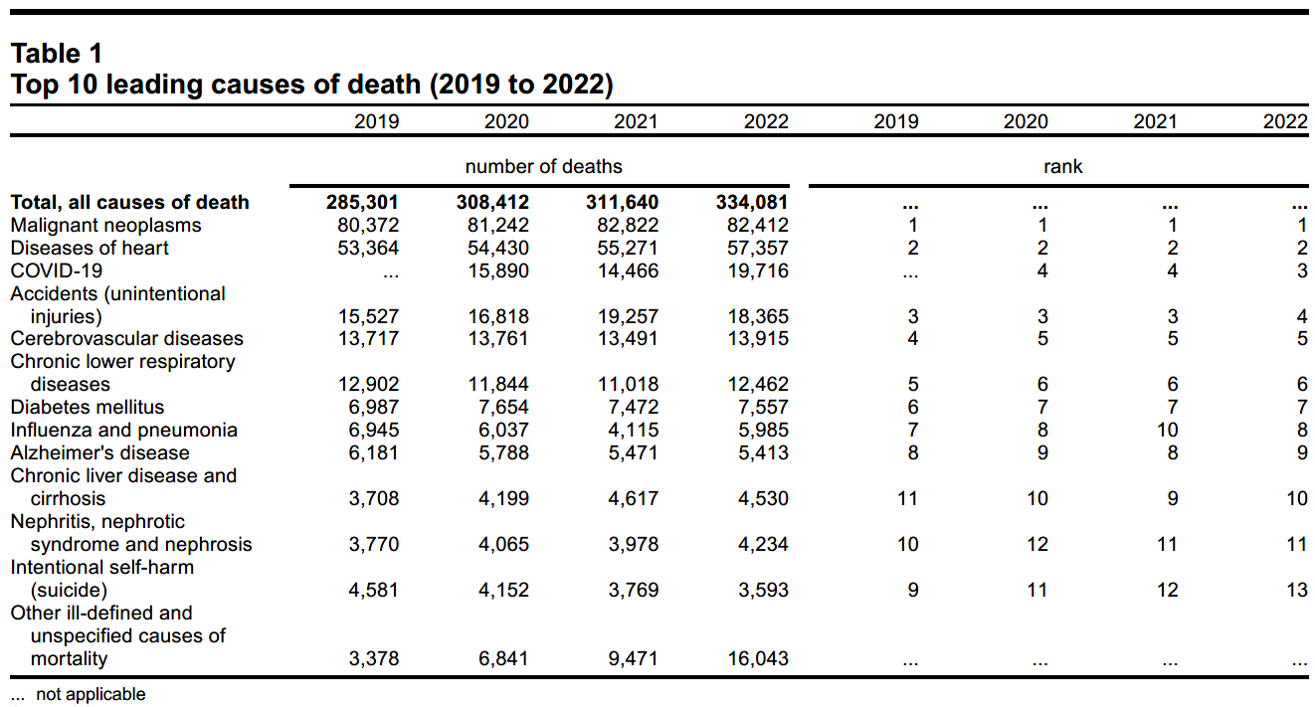

*475% Increase*

*14.25% Increase*

*26% Increase*

*7.5% Increase*

*25% Increase*

*280% Increase*

*203% Increase*

*mRNA Injections*

*Introduced*

**Source(s): Table** [**13-10-0394-01**](https://www150.statcan.gc.ca/t1/tbl1/en/tv.action?pid=1310039401)**.**

*In November 2023 Stats Can finally released the Yearly Death Statistics up until the end of 2022.*

* *Table 1 above shows the Top 10 leading causes of death (2019 to 2022). Notice the recorded numbers of death across the category in the last line,* ***“Ill-defined and unspecified causes of mortality”,*** *the increases for 2021 and 2022 are huge. One might ask why are there so many more unspecified causes of death then in 2019 and even 2020? The most obvious impacting factor that seems likely to have contributed to this increase is the introduction of the Covid-19 Injections in early 2021, this followed by ongoing mmRNA boosters, and the additional age cohorts for which the injections were recommended and administered.*

*Stats Can provides explanatory notes on their webpages for the possible reasons for increases in mortality, why would they fail to identify the impact of the “vaccines” as a possibility for further investigation. Could it be that the Canadian Government is in damage control mode after pressuring and even forcing Canadians to be injected with experimental “vaccines” that included a novel mmRNA delivery system never before used on humans that have proven to be not only ineffective, but also unsafe.*

*Even the increase in unspecified causes of mortality in 2020 seems to be void of any reasonable explanation. It seems highly likely, with all that is now known, that it was the governments’ application of unscientific “pandemic” abatement strategies that contributed to this increase in deaths. This would include the impacts of over-masking, the isolation of the elderly caused by lock-downs, and shuttering of businesses, churches, schools, etc. The exact mechanisms of these actions that would lead to higher death rates may not be fully understood, but there are hundreds of scientific studies and articles from various experts that show that the actions taken by governments during the C-19 outbreak were unscientific, misguided, and damaging.* [*https://brownstone.org/articles/more-than-400-studies-on-the-failure-of-compulsory-covid-interventions/*](https://brownstone.org/articles/more-than-400-studies-on-the-failure-of-compulsory-covid-interventions/)

* *I showed this table to my family physician, and she noted that the death numbers in 2020, listed as Covid-19, looked very much like the numbers that one would see in a bad flu year.*

* ***Accidental Deaths*** *also show a large increase in 2021 and 2022 over 2019.*

*It is known that the mmRNA vaccines, amongst other side effects, cause heart attacks and strokes. It is not difficult to conceive that vaccinated people who appear healthy might have a stroke or heart attack at a critical moment resulting in a drowning, fatal fall, or motor vehicle crash. In these types of incidents, if there is no autopsy completed, or the stroke is undetected, the death could easily be attributed to the visible or otherwise potential death causing indicia consistent with an “accidental” death.*

* ***Deaths attributed to Covid-19***

*Those deaths that are being attributed to the Covid-19 virus are the subject of some suspicion as there has not been a concerted effort to identify those individuals who died ‘with’ Covid-19 and those who died ‘from Covid-19’.*

*What is revealing is that the Covid 19 death rate in 2022 was 26% higher than in 2020 when the government claimed a “pandemic”, and commenced implementation of every foolish restriction backed by their “the science” in responding to it. Further, by 2022 we had a population of which somewhere over 80 percent were considered “vaccinated” against Covid-19, yet the deaths are 26% higher than the years with no vaccines.*

*What was most disturbing was that by 2022 the statistics for Covid-19 in Ontario, across Canada, and in countries around the world showed that those who received the Covid-19 “vaccines” were dying at a much greater rate than those who remained un-injected. By mid 2022 the statistics comparing 100,000 of each cohort (No-shots, 2-shots and 3-shots) showed that the Triple “vaxxed” were 3 times more likely to contract C-19 and die from it than the unvaxxed. And for the 2-shot “vaxxed”, they were 2 times higher in contracting C-19, and dying from it than the unvaxxed group. As for the whole response to the panic-demic that was turned over completely to the medical establishment and pharma enriched “professors”, instead of a balanced properly convened Emergency Management Team, their only real concern was vaccinating to avoid filling up the hospitals. How is it these fools have nothing to say when in 2022 75% of hospitalizations for C-19 where amongst the vaccinated?*

*Barry Farndon*

**SUBJECTIVE COMMENTS BY Canadian Gov “EXPERTS” Included with the Table**



[**https://www150.statcan.gc.ca/t1/tbl1/en/tv.action?pid=1310039401**](https://www150.statcan.gc.ca/t1/tbl1/en/tv.action?pid=1310039401)

**Comments by Gov of Canada:** <https://www150.statcan.gc.ca/n1/pub/71-607-x/71-607-x2021028-eng.htm>

**Provisional weekly estimates of the number of deaths, expected number of deaths and excess mortality**

**Exploring the trends: Provisional death estimate insights**

The number of excess deaths is measured as the difference between the number of observed deaths and the number of expected deaths over a certain period of time. Using excess mortality insights to assess the direct and indirect impacts of the pandemic can help to understand when there are more deaths during a period of time than would be expected for that period.

To account for pre-pandemic trends in mortality, including the effects of a growing and aging population, Statistics Canada is using an approach that has been adopted by other countries to estimate expected deaths. There are a number of ways to measure excess mortality and each method has challenges, including how to properly estimate the number of expected deaths that would occur in a non-COVID‑19 context compared to the current death counts. It should be noted that, even without a pandemic, there is always some variation in the number of people who die in a given week. This means that the number of expected deaths should fall within a certain range of values.

Beyond deaths attributed to the disease itself, the pandemic could also have indirect consequences that increase or decrease the number of deaths as a result of various factors, including delayed medical procedures, [increased substance use, or declines in deaths attributable to other causes, such as influenza](https://www150.statcan.gc.ca/pub/45-28-0001/2020001/article/00076-eng.htm).

**Recent key insight: National trends**

Prior to the emergence of the Omicron variant of COVID‑19, four significant periods of excess mortality were observed nationally since the start of the pandemic. From March 2020 to June 2020, followed by a longer period of excess deaths from September 2020 **to February 2021**. There was a shorter period experienced in **May 2021**, and another coinciding with the emergence of the Delta variant, from **July 2021 to December 2021**.

Since that time, a period of excess was observed beginning in January 2022. Over the nine-week period starting in **January 2022 and ending March 5, 2022**, there were 8,959 excess deaths, or **16.2% more deaths than expected**. While this corresponded with a period of increased COVID-19 activity—more than 6,985 deaths were directly attributed to the disease — it **suggests** that other factors might be contributing to the excess. For example, a record number of accidental poisonings (including drug overdoses) were reported in 2021.

Over these same nine weeks, Canada had its deadliest week of the pandemic so far, and most provinces experienced periods of significant excess mortality including Newfoundland and Labrador, Nova Scotia, New Brunswick, Quebec, Ontario, Saskatchewan, Alberta and British Columbia. This differed from previous periods of excess mortality, which were generally characterized by greater than expected mortality in only the four largest provinces.

Nationally, the number of deaths fell within the range of what would be expected had there been no pandemic through the rest of March 2022.

Starting in **mid-April 2022, however, a period of significant excess mortality** was once again observed **until early June**. Over the course of these **eight weeks**, there were 3,799 (or 8.6%) more deaths than expected and at least 2,430 deaths attributed to COVID-19. The provinces that experienced this excess were Alberta, British Columbia and Saskatchewan.

The most recent period of significant excess mortality was observed **starting in July 2022** and **continued through to the end of the year**.

While the first period of excess mortality in 2022 was driven by excess mortality in Quebec and Ontario, the remaining periods of excess mortality were mostly driven by the westernmost provinces as well as Quebec and Ontario. In fact, Alberta and British Columbia had higher than expected weekly deaths through much of 2022, and, while nationally, excess mortality has not been observed in 2023, the two westernmost provinces continue to experience excess mortality.

